
100
100
96
91

Performance
http://127.0.0.1:8080/Clase%2015/
Accessibility
Best Practices
SEO

100
Performance
Values are estimated and may vary. The performance score is calculated directly from these metrics. See calculator.

0–49 50–89 90–100

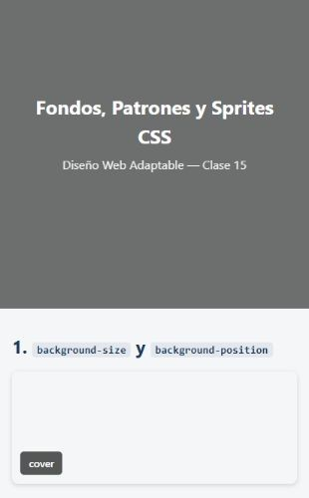

METRICS Expand view

First Contentful Paint

0.8 s
Largest Contentful Paint

1.1 s

Total Blocking Time

0 ms
Cumulative Layout Shift

0

Speed Index

0.8 s
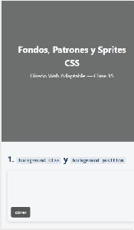
Show audits relevant to: All FCP LCP TBT

INSIGHTS

Render-blocking requests — Est savings of 40 ms

Network dependency tree

Document request latency — Est savings of 5 KiB

LCP breakdown

These insights are also available in the Chrome DevTools Performance Panel - record a trace to view more detailed information.

DIAGNOSTICS

Minify CSS — Est savings of 4 KiB

Avoid long main-thread tasks — 2 long tasks found

More information about the performance of your application. These numbers don't directly affect the Performance score.

PASSED AUDITS (23) Show

100

Accessibility
These checks highlight opportunities to improve the accessibility of your web app. Automatic detection can only detect a subset of issues and does not guarantee the accessibility of your web app, so manual testing is also encouraged.

ADDITIONAL ITEMS TO MANUALLY CHECK (10) Show

These items address areas which an automated testing tool cannot cover. Learn more in our guide on conducting an accessibility review.

PASSED AUDITS (16) Show

NOT APPLICABLE (47) Show

96

Best Practices

GENERAL

Browser errors were logged to the console

TRUST AND SAFETY

Ensure CSP is effective against XSS attacks

Use a strong HSTS policy

Ensure proper origin isolation with COOP

Mitigate clickjacking with XFO or CSP

Mitigate DOM-based XSS with Trusted Types

BROWSER COMPATIBILITY

Baseline Features

PASSED AUDITS (12) Show

NOT APPLICABLE (2) Show

91

SEO
These checks ensure that your page is following basic search engine
optimization advice. There are many additional factors Lighthouse does not score here that may affect your search ranking, including performance on
Core Web Vitals. Learn more about Google Search Essentials.

CONTENT BEST PRACTICES

Document does not have a meta description

Format your HTML in a way that enables crawlers to better understand your app’s content.

ADDITIONAL ITEMS TO MANUALLY CHECK (1) Show

Run these additional validators on your site to check additional SEO best practices.

PASSED AUDITS (7) Show

NOT APPLICABLE (2) Show

Captured at Sep 8, 2026, 5:05 PM CST
Emulated Moto G Power with Lighthouse 13.4.1
Single page session

Initial page load Slow 4G throttling Using Chromium 152.0.0.0 with devtools

Generated by Lighthouse 13.4.1 | File an issue

